Sema SMS User Guide

A Product of Shujaa Solutions Limited



2013

www.shujaa.co.ke

http://sema.shujaa.mobi

info@shujaa.co.ke



INFORMATION IN THIS DOCUMENT IS PROVIDED IN CONNECTION WITH SHUJAA SOLUTIONS’ PRODUCTS. NO INTELLECTUAL PROPERTY RIGHTS, LICENSE, EXPRESS OR IMPLIED, BY ESTOPPEL OR OTHERWISE, IS GRANTED BY THIS DOCUMENT, EXCEPT AS PROVIDED IN SHUJAA SOLUTIONS’ TERMS AND CONDITIONS OF SALE FOR SUCH PRODUCTS. SHUJAA SOLUTIONS ASSUMES NO LIABILITY WHATSOEVER, AND SHUJAA SOLUTIONS DISCLAIMS ANY EXPRESS OR IMPLIED WARRANTY, RELATING TO SALE AND/OR USE OF SHUJAA SOLUTIONS’ PRODUCTS INCLUDING LIABILITY OR WARRANTIES RELATING TO FITNESS FOR A PARTICULAR PURPOSE, MERCHANTABILITY, OR INFRINGEMENT OF ANY PATENT, COPYRIGHT OR OTHER INTELLECTUAL PROPERTY RIGHT.

The Programs (which include both the software and documentation) contain proprietary information; they are provided under a license agreement containing restrictions on use and disclosure and are also protected by copyright, patent, and other intellectual and industrial property laws. Reverse engineering, disassembly, or decompilation of the Programs, except to the extent required to obtain interoperability with other independently created software or as specified by law, is prohibited.

The Programs are not intended for use in any nuclear, aviation, mass transit, medical, or other inherently dangerous applications. It shall be the licensee's responsibility to take all appropriate fail-safe, backup, redundancy and other measures to ensure the safe use of such applications if the Programs are used for such purposes, and Shujaa Solutions disclaims liability for any damages caused by such use of the Programs.

Shujaa Solutions may make changes to specifications and product descriptions at any time, without notice.

No part of this publication may be reproduced, transmitted, transcribed, stored in a retrieval system, or translated into any language or computer language, in any form or by any means, electronic mechanical, magnetic, optical, chemical, manual, or otherwise, without the prior written permission of Shujaa Solutions Ltd.

Copyright © 2013 by Shujaa Solutions Ltd. All rights reserved.

All other trademarks are property of their respective owners.

Shujaa Solutions Ltd.

InTrade Africa Place, Kauria Close

Off Muthangari Road, Lavington

P.O. Box 48183 – 00100

Nairobi, Kenya

Contents

Introduction 3

Before you start 3

Getting Into The SemaSMS System 4

Using Basic Features 7

First things First - Adding Groups 7

Adding Contacts 10

Sending SMS 13

Sending SMS to Groups on your phone 16

Receving SMS 17

Advanced Features 19

1. Forwarding sms messages to SemaSMS inbox, email or mobile 20

2. Sending Group sms from mobile 20

3. Using Subscription Service 21

4. Auto-reply 22

5. Quiz Response Collection 22

6. Poll Response Collection and web /RSS publishing 23

7. SMS content publishing on web / RSS 24

8. Publishing Contacts in Groups for Shared Access with Other users 25

9. Administrator Features 25

# Introduction

SemaSMS is a turnkey web based application that allows for the sending and receiving of SMS through a short code number. It is designed to make the process as easy as the sending and receiving of email.

Some of the features include:

* Ability to add, modify and delete a Contact in an account;
* Ability to add, modify and delete a Group in an account. A Group is a list of Contacts that can simultaneously receive a message;
* Send SMS to an individual Contact or Group;
* Receive SMS into an Inbox;
* Creation and management of SMS templates. These are pre-defined messages that can be sent to a Contact or Group;
* Support for multiple network operators;
* Import and export of Contacts;
* Email-to-SMS and SMS-to-Email.

These are but a few of the exciting features that make it simple to use SemaSMS as a complete management solution for your SMS needs.

# Before you start

Do you have a login username and password for your company provided by Shujaa Solutions Support?

If not, please email [support@shujaa.co.ke](mailto:support@shujaa.co.ke) from your office email address with the following details: details of your company, your desired username, your mobile phone number and your preferred email address for any communications relating to the system.

## Getting Into The SemaSMS System

Once you have your username and password from [support@shujaa.co.ke](mailto:support@shujaa.co.ke), please open your browser and go to <http://sema.shujaa.mobi> (or press ctrl and click on this link - <http://sema.shujaa.mobi>). You should see the following window.

Enter your username and password and click submit.

You should now be taken to the following window. 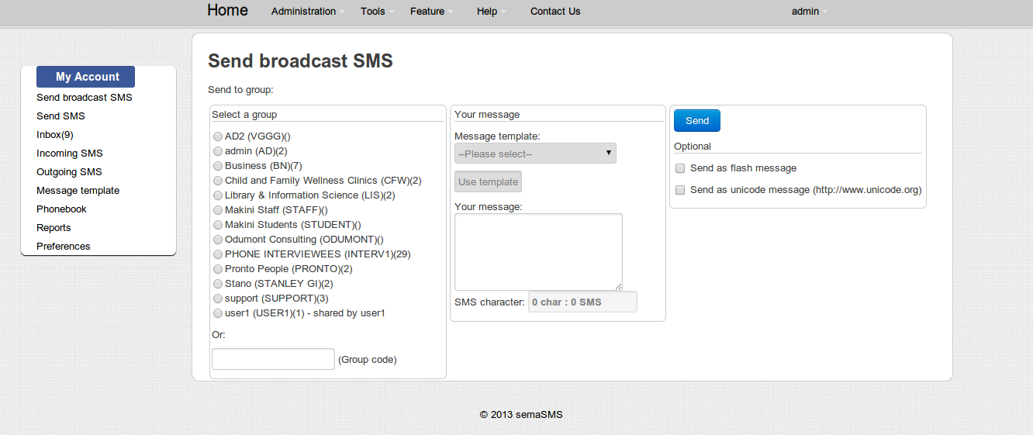

Before you proceed to sending messages, please make sure that your account details are correct. To do this click on “Preferences”.

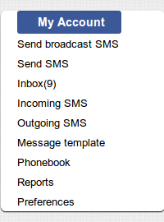

This will bring a window (shown below) that will allow you to change various things. We recommend you change or complete the following;

1. Your password – This ensures that only you controls who has access to the system
2. Your Personal Information section – Complete all items and ensure that the phone number is the one you will use in relation to your SemaSMS account. Your email should also be the one where the system can send you SemaSMS related messages.
3. Application information – Select if you would like your messages forwarded to your SemaSMS inbox, your email or your phone (please see the Advanced features section of this manual).

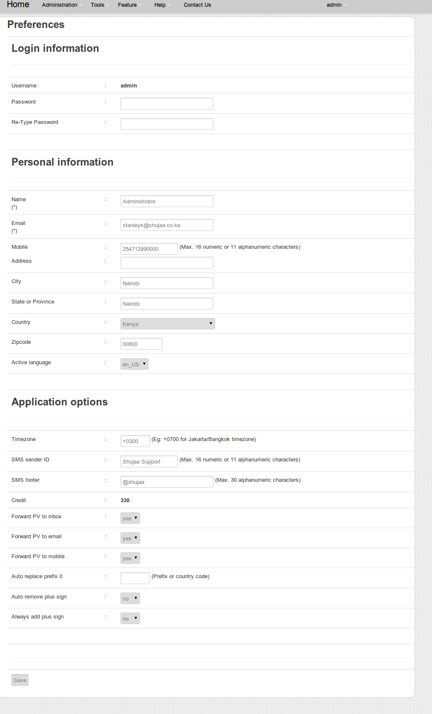

# Using Basic Features

## First things First - Adding Groups

We know you are excited and want to start sending SMS. However, in order to make it easier for you later, we suggest you first start by adding the names and phone numbers of the people that you need to send messages to.

In order to add contacts, select “Phonebook” under my account on the left side of the page (click on Phonebook using your mouse to select). Please view the diagram shown below:

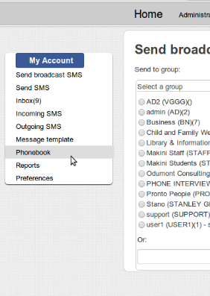

Clicking on Phonebook should take you to this window;

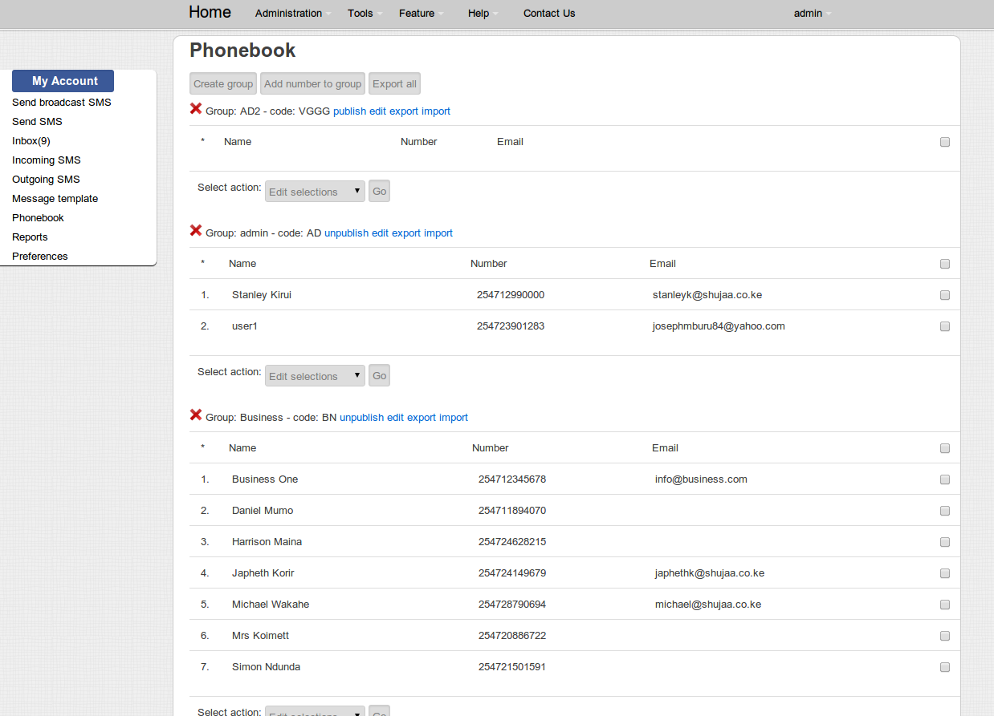

In order to help you organize your contacts, you first need to create a group then add people’s contacts to that group. This will enable you to send messages to entire groups using the SMS broadcast feature. Click on create group and complete this form;

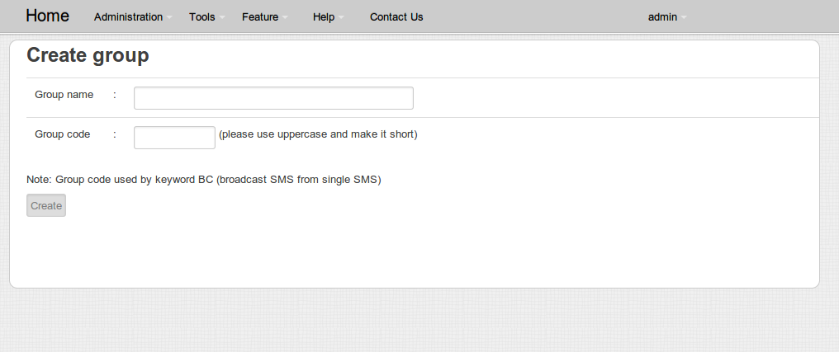

Enter the group name, choosing a name that describes what you intend to use this group to communicate or the description of the group of people. E.g. “HR staff”, “Youth Group” etc.

Enter a group code with a short code in capital letters, numbers or symbols. Choose a code that resonates with the group name e.g. if your group is HR staff your code could be HR, or if your group name is “Youth Group - Nairobi Girls 16 to 18” then your code could be “NG16:18”. (Do not include the quotations!).

Once the group is created you will be kept on the same “create group” page. With a message in the format: “Group code has been added (group: ‘groupname’ code: ‘codename’)”

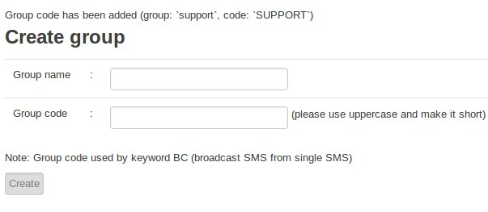

You can add other groups that you need e.g. if you are a school you may wish to add a group for each class. Once you have created all your groups, you now need to add contacts to each group.

## Adding Contacts

Click on, phone book again;



And you will be brought back to this window;

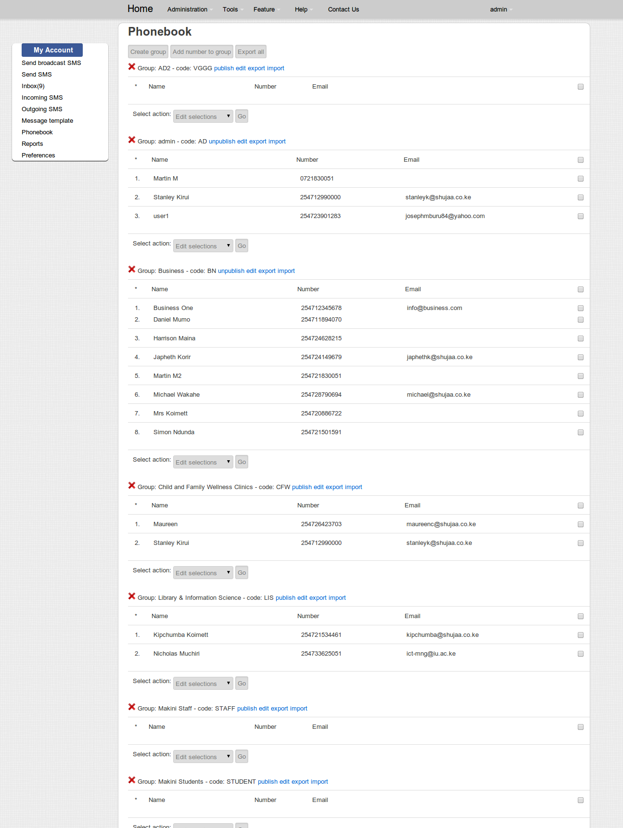

You will see the groups you have created in the previous procedure. You now need to add contacts. To do this click Add number to group and you will be taken to this screen:

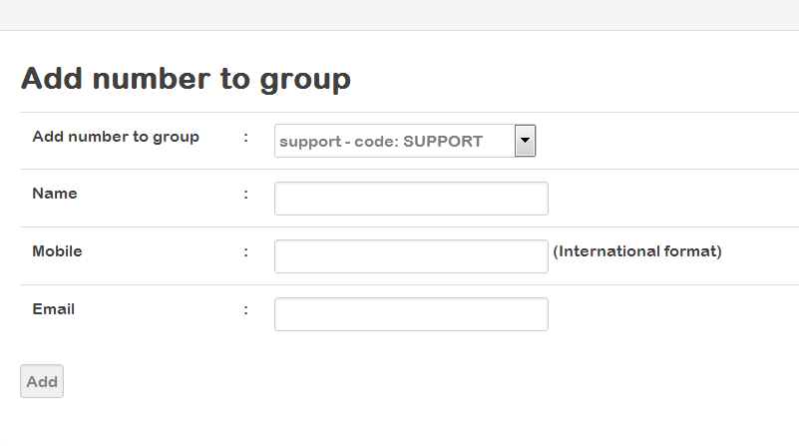Here you should enter the person’s full names (if you have them) or just a nickname if it’s unique. The mobile number must begin with the country code e.g. 254 for Kenya following by the mobile number without the zero in front.

For example if your number is 0710123456, then the mobile number will be entered as 254710123456.

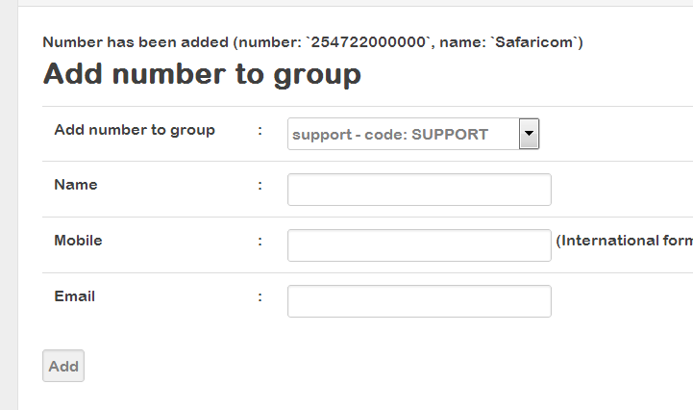Click on add, and you will be return to this window but there will be a message at the top of the window. If you are successful the window will look like this image.

Otherwise, if the mobile number already exists, the system will respond as below but will not add the contact again. The message displayed at the top is: “Number already exists (number: ‘254…….’ name: ‘contact name’)”

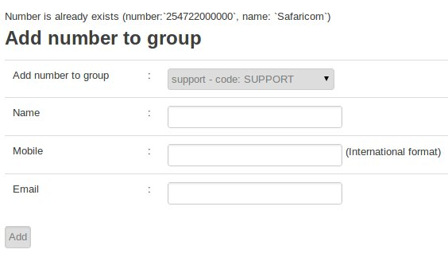

## Sending SMS

Now we are ready to send SMS! There are two options to send SMS messages;

1. Sending to a single mobile number or selected individuals from your phonebook;
2. Sending to groups

**Sending SMS to an Individual or Individuals on your phone book**

At the homepage,click on “Send SMS” under My Account

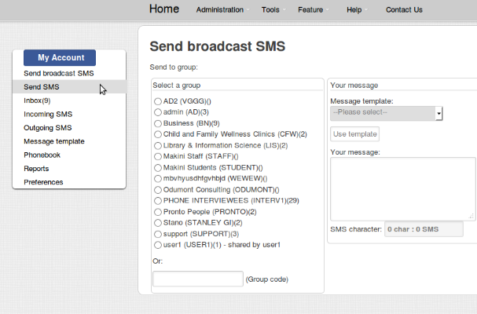

You will be brought to a window that looks as below:

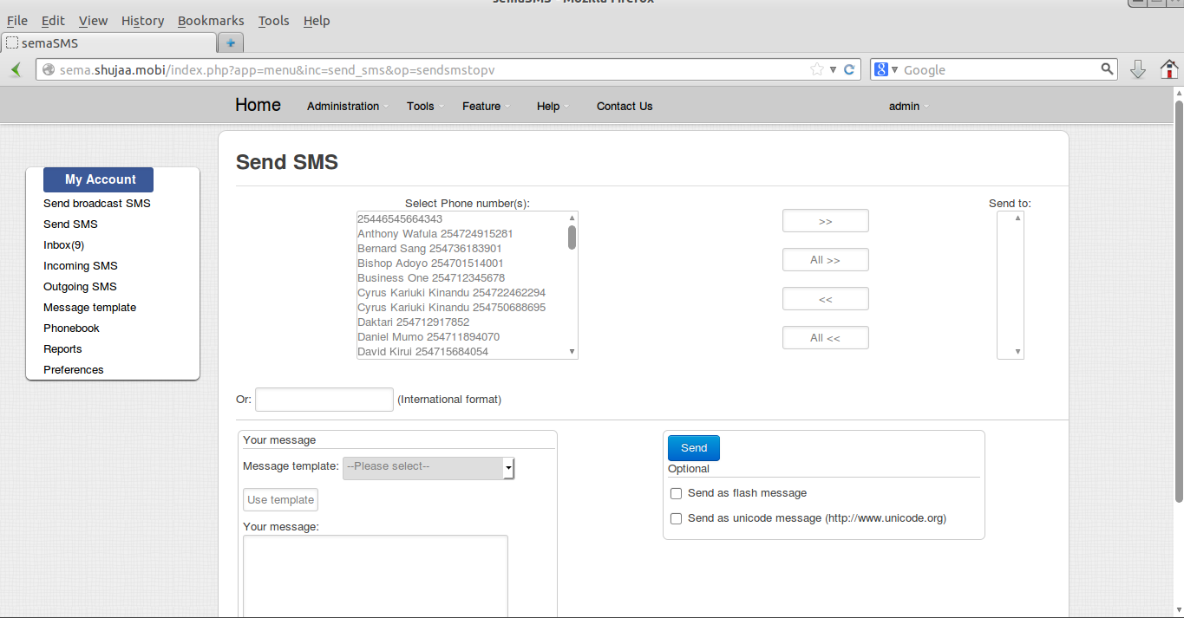

Select a name & number from the box “phone number(s)” and click on the arrow  . If the person you want to send a message is not already in your phonebook & you do not wish to save their contact details, you can enter their mobile number in the following box;

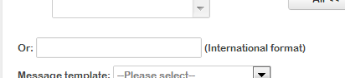

Enter the number in the box between “Or” and “International format”. Remember to use the correct mobile number format (254722123456).

Once you have selected the contacts or entered the number of the recipient, type your number in the message window. Once you are done, click on the send button. 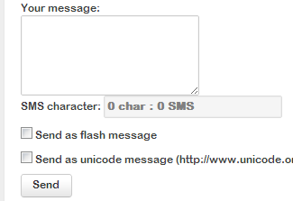

If the message is sent successfully you shall see a message at the top of the send sms window as follows;

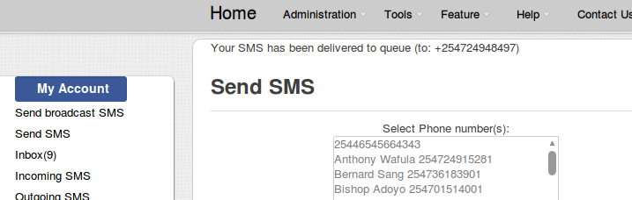

## Sending SMS to Groups on your phone

Under my account,click on “Send broadcast SMS”

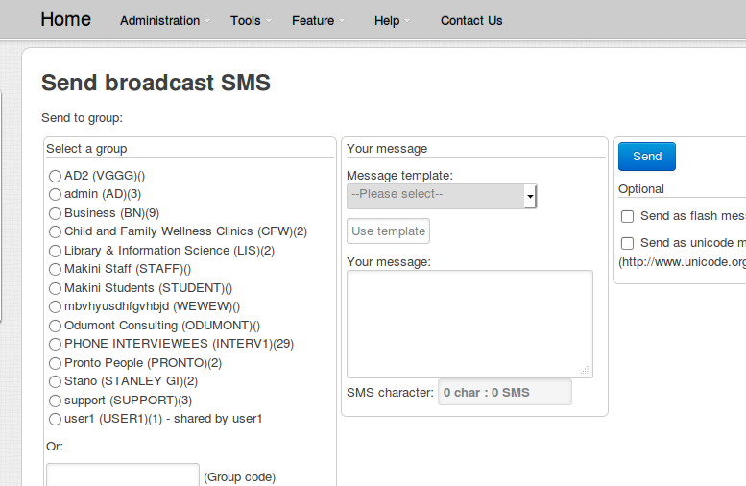You will be brought to a window that looks as aside. Select the group by pressing here and selecting the group you want to send text message to. Alternatively if you remember

group code you can enter it direct into the box next to (Group code).

Enter the message that you want the entire group to receive here.

Click send and your message will be sent.

You will be returned to the same window with a message showing that it was sent successfully.

## Receving SMS

**Receiving SMS – How does someone send a message to my Sema inbox?**

SemaSMS allows each account holder to receive all messages addressed to them via their inbox. In order for you to receive messages, you need to tell anyone sending message to you 3 things;

1. The number which they will send the message to. This will be the number that SemaSMS is configured to use – could be a four digit code (e.g. 2024) or an ordinary phone number.
2. Your username, that is, the username that you use to log into SemaSMS. In my case this would be “Trainer” or “admin”!
3. The command to tell the system what to do with the message. For receiving the SMS the command is “PV”.

Thus in order for someone to send a message to me, where my username is admin and the phone number is 2024, then someone who wants me to receive their message should create a new sms on their phone and type in ***any*** of the following commands before the message;

* PV ADMIN This is a message to test sending sms direct to the admin’s account
* pv admin This is a message to test sending sms direct to the admin’s account

Hence you will replace username admin with your own. So if your username is Kamlesh then for someone to send you a message the command before the message is “PV Kamlesh” or “pv Kamlesh”.

**Receiving SMS –How do I read the message(s) in my Sema inbox?**

You can read the messages received by going to the inbox under “My Account” as follows;

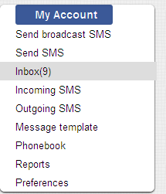

# Advanced Features

Beyond sending and receiving messages from the system, SemaSMS allows you to perform various convenient functions that would enhance communications within your organization or outside your organization to clients, members, communities etc. Our sales and support team will be able to articulate your needs and show you which features will suit your needs.

Currently, the following advanced features are available for your use and will be illustrated in this document (click on the highlighted links for instructions);

1. Setting your account to ***forward incoming sms messages*** to ***SemaSMS inbox***, ***email*** or ***mobile number***.
2. ***Sending Group sms from mobile***: You can send a message from your phone to groups of contacts in your account.
3. Enabling a ***subscribe*** feature where users can subscribe or unsubscribe to/from a particular subscribe group from their mobile phones. This allows you to send message(s) to those subscribed to this type of group.
4. ***Auto-reply*** feature that allows you to setup an automatic reply to anyone who uses the key word for the auto-reply.
5. SMS ***quiz*** tool allows you to use SemaSMS to receive & store answers from your audience and respond to them automatically depending on the answer – correct or wrong.
6. SMS ***poll*** tool allows you to use SemaSMS to receive votes from your audience and automatically allocate votes depending on the answer. It shows the percentage of each item voted for and doesn’t allow multiple voting from one phone number.
7. SMS ***Board*** tool allows you to use SemaSMS to receive messages and see all messages in a special web page or via RSS link for mobile viewing.
8. ***Publish***ing your contacts so that other users of the system can use your contacts.

## Forwarding sms messages to SemaSMS inbox, email or mobile

In order to allow all messages addressed to you to be forwarded to you inbox, email or mobile, you should

* Go to “Preferences” under “My Account”.
* Check that your mobile number is in the correct format (254722123456)
* Check that your email is correct.
* Select yes for the options you want activated as shown below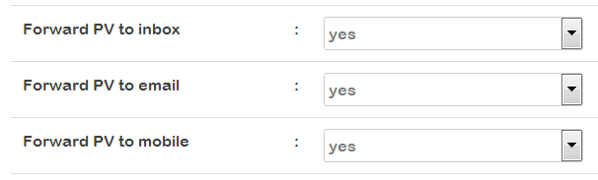

**Notes:**

By default forwarding to inbox is enabled as it’s the core function that enables the system to support multiple users on one system i.e. it allows an “address” function, similar to email.

Moreover, for email to be sent the administrator of SemaSMS must have configured the email sending functionality in the system.

For messages to be forwarded to your phone, you must have sufficient credit in your account! You can monitor your balance on the preferences page.

## Sending Group sms from mobile

The user account owner of a SemaSMS account can send messages to any published group that they created, as per the create group section of this manual. In order to send a message to a group you need to have the following in place;

* The phone with the same number as you entered in your account preferences.
* The number of the SemaSMS system that you are using (short code e.g. 2024).
* The code for the group that you want to send to (e.g. we use code STAFF as an example)

When all the above are in place, you can send a message from your registered number by texting with the following format;

*BC STAFF This is a message to all staff!*

BC is the key word that tells SemaSMS that the message is to be forwarded the group whose code is the next word, in this case STAFF, and the message to be forwarded starts immediately after the group code. This functionality is not case sensitive and can thus also be – “*bc staff this is a message to all staff*” or “*Bc Staff This is a message to all staff*”. However, the message is case sensitive as is a normal sms!

**Notes:**

You can only forward messages to your own groups with the number that you recorded in preferences.

Your account must have sufficient credit as well (You can check your balance in “My Account”-> “preferences”).

If you want to forward a message to someone else’s group, the easiest way would be to forward your message to them and request them to send it. We may allow multiple number sources in later versions.

## Using Subscription Service

What is SMS subscribe system? Answer: Administrator can add SMS keyword which people can subscribe to. Once a number subscribed, administrator can send message to all subscribed number at once.

Howto use SMS subscribe system? Answer: Add new subscribe or list/edit/delete it. Write down subscribe keyword, subscribe message, and unsubscribe message. When a number has subscribed the system will automatically send a subscribe message, and when a number has unsubscribe the system will automatically send an unsubscribe message. Add message to each subscribe keyword, this message will be sent to all subscribed number.

Tell people to send SMS to SemaSMS gateway mobile number with format: [SUBSCRIBE KEYWORD] [INSTRUCTION] eg: SEMASMS REG SEMASMS UNREG theclub REG theclub off

## Auto-reply

Feature currently unavailable. Please ask for an alternative way to create an auto – reply using the quiz functionality.

## Quiz Response Collection

What is SMS quiz system? Answer: Administrator can add quiz keywords, questions and answers, and define message reply for participants. Once a participant send message with quiz keyword and quiz answer keyword, system will reply with a message to tell participant whether the answer is correct or incorrect.

How to use SMS quiz system? Answer: Add new quiz or list/edit/delete it.

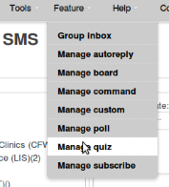

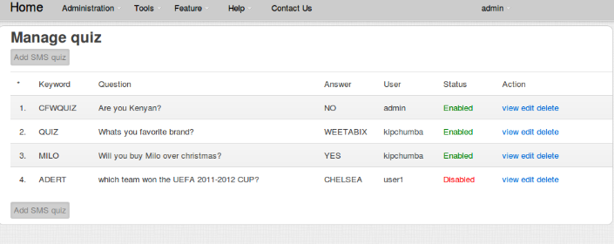

Write down quiz keyword, quiz question, quiz answer and message to participants for correct and incorrect message. Tell participants to send SMS to SemaSMS mobile number with format: [QUIZ KEYWORD] [ANSWER KEYWORD] eg: soccer Germany

## Poll Response Collection and web /RSS publishing

How to use SMS poll system? Answer: Add new poll or list/edit/delete it

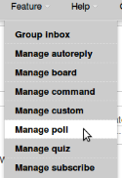.

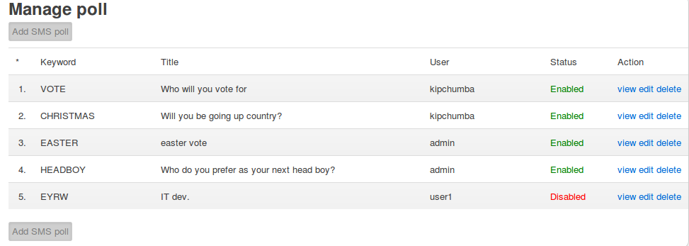

Write down poll keyword and each choice keyword you have defined. Tell voters to send SMS to SemaSMS SMS gateway mobile number with format: [POLL KEYWORD] [CHOICE KEYWORD] eg: food chicken pres 3

Howto show results of SMS poll in other website? Answer: For example polling with keyword PRES Webpage for poll named PRES would be accessable trough this url:

[http://sema.shujaa.mobi/index.php?app=webservices&ta=sms_poll&keyword=VOTE](http://sema.shujaa.mobi/index.php?app=webservices&#38;)

Other parameter you can use: bodybgcolor : set body background color refresh=yes : check latest incoming sms and refresh webpage output Use IFRAME html tag. eg:

## SMS content publishing on web / RSS

What is SMS board? Answer: Administrator can add new SMS board with keyword other than PV and BC. Incoming SMS with the specified keyword will be handled by SMS board and be forwarded to a unique web page served by SemaSMS. Incoming SMS will also be forwarded to an email specified in each SMS board keywords.

If I add SMS board, how to access web page for a keyword? Answer: For example you've added SMS board with keyword INFO. The web page for keyword INFO (referred as SMS board INFO) would be accessable through this url: [http://sema.shujaa.mobi/index.php?app=webservices&ta=sms_board&keyword=INFO](http://sema.shujaa.mobi/index.php?app=webservices&#38;)

Other parameter you can use to refine the disSema: line : show x line number of rows bodybgcolor : set body background color oddbgcolor : set odd row backround color evenbgcolor : set even row backround color eg:

[http://sema.shujaa.mobi/index.php?app=webservices&ta=sms_board&keyword=INFO&line=15](http://sema.shujaa.mobi/index.php?app=webservices&#38;)

Can I retrieve incoming SMS for that a keyword in XML format? Answer: Yes, incoming SMS will be formatted in RSS 0.91, and accessible through this url:

[http://sema.shujaa.mobi/index.php?app=webservices&ta=sms_board&keyword=INFO&type=xml](http://sema.shujaa.mobi/index.php?app=webservices&#38;)

Other parameter you can use to refine the XML output: line : show x line number of rows in xml file eg: [http://sema.shujaa.mobi/index.php?app=webservices&ta=sms_board&keyword=INFO&type=xml&line=15](http://sema.shujaa.mobi/index.php?app=webservices&#38;)

How to put that web page on my main website? Answer: Use IFRAME html tag. Customize your IFRAME to match your main website look and feel. eg:

Note: other solution may be available.

## Publishing Contacts in Groups for Shared Access with Other users

If you have finished adding contacts to all your groups and would like to share the groups with other users of semaSMS, then you need to activate each group by going back to phonebook window (under My Account), and click on the blue publish text ( ) in this window. The text displays, “Publish”.

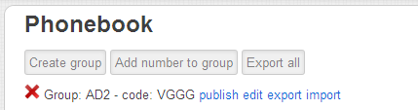

After it has been clicked it will look like this:

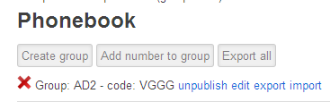

Notice the message at the top saying that the group has been published. This is not to be used if you want your contacts to be private to and protected from other users of the system. You should only publish if you want others to use your contacts on your behalf.

## Administrator Features

* ***SMS Rate:*** What is Manage SMS rate menu in Administration drop-down menu? Answer: It is where administrator can set rate by prefix. What is term 'rate' means? Answer: Rate is credit value per SMS sent. What is term 'credit' means? Answer: Credit is money value equivalent a user have on their balance. What if user send SMS to destination that is not configured in Manage SMS rate? Answer: Default SMS rate in Main configuration menu will be used instead. How to change credit per user ? Answer: Go to Manage user menu in Administration drop-down menu and edit each user. What kind of SMS being rated ? Answer: Only sent SMS.
* ***SMS COMMAND:*** Can I command server to do something? Answer: Yes. Login as admin user and configure SMS command feature. How to setup SMS command? Answer: Add new SMS command and associate a command that will be executed on incoming SMS that matched your keyword. On incoming SMS, SemaSMS will pass variables to the command. They are: {SMSDATETIME} replaced by incoming SMS date/time {SMSSENDER} replaced by sender mobile phone number {COMMANDKEYWORD} replaced by incoming SMS keyword {COMMANDPARAM} replaced by incoming SMS parameter. How to utilized a defined SMS command? Answer: Send SMS to your SemaSMS with format: [COMMAND KEYWORD] [COMMAND PARAM] eg: reg email devteam@Semasms.org retr pop3 pop3.ngoprek.org devteam mypwd uptime. What commands are available from SMS command? Answer: Any commands are available to be executed from SMS command.
* ***SMS CUSTOM:*** What is SMS custom? Answer: SMS custom is used to process incoming SMS by passing the SMS information to another application in other server using HTTP. [sender] --GSM-- [SemaSMS] --IP-- [other host processing SMS]. How to setup SMS custom? Answer: Add new SMS custom from menu, and then set custom URL of the host handling SMS. On incoming SMS, SemaSMS will pass variables to the URL. They are: {SMSDATETIME} replaced by SMS incoming date/time {SMSSENDER} replaced by sender mobile phones number {CUSTOMKEYWORD} replaced by custom keyword {CUSTOMPARAM} replaced by custom parameter. How to utilized a defined SMS custom? Answer: Send SMS to your SemaSMS with format: [CUSTOM KEYWORD] [CUSTOM PARAM] eg: reg email devteam@Semasms.org retr pop3 pop3.ngoprek.org devteam mypwd uptime.

